**Website Correction**

**Home Page**

* Adding good quality company logo for header
* Adding land number for Call us **(0484 2989297)**
* Facebook account is old add current account
* Add social media **(LinkedIn and YouTube)**
* Change header 3 pages photos
* **Header Slide 1**- Correct word - Complete solution for LPG & PNG Fuel Piping System
* Change quote
* **Header slide** **2**- Change heading, Change quote
* **Header slide 3**- Change heading, change quote
* Not working “**KNOW MORE**” button
* Remove ISO and MSME logos and add another picture
* Remove “word from director”
* Change heading style
* Heading – **Sreelakshmi Energy Systems Pvt. Ltd.**
* Use good color in heading
* About company –

(We are an ISO 9001:2015 Certified & MSME Registered Company established in the year 2006 engaged in the business as Consultant Engineers & Contractors for LPG/PNG Fuel Piping Installations, Gas Monitoring System, Gas Detection System, Industrial Burners & Heat Pumps.

During these years we have been associated with all major industrial establishments, Construction and Real estate developers, IT Campuses, Hotels, Tourism & Hospitality industries, Medical & Education sector’s etc.  
We have made an impact by creating state of the art LPG infrastructure for Industrial, Hospitality and Residential projects with International quality standards and unmatched Customer service.)

* Avoid blank space
* Heading – **Message from Director**
* Correct word – (Message from Director May I take this opportunity to thank our valued customers, whose continued patronage and confidence in our work inspires us to extend the best of services and enables us to provide value for their money. I always wanted to push my company to more prosperous milestones. I always perceived my company as a unit that could make a difference with its quality and competitively priced products. Taking a path less travelled, I expanded Sreelakshmi Energy Systems Pvt. Ltd. a part of a group having 40 years of experience in oil & gas retail business completing many more LPG projects including installations for industries, hotels & restaurants, shopping malls, education institutions and more than 75,000 residential apartments. We are also principle contractors of IOAGPL & AGP dealing with PNG domestic & commercial installations from Ernakulum GA to Trivandrum GA.

We are committed to total customer satisfaction by identifying their specific needs, translating them into quality products and providing dependable after-sales-services.

For all our success, the management is indebted to our most dedicated team of employees who are always ready to accept new ideas and concepts, shoulder responsibilities and meet challenges triggering the growth of the organization and customer satisfaction.

Once again, we seek continued patronage of our valued customers and thank our well-wishers who have contributed to the growth of the organisation. The journey of Sreelakshmi Energy Systems Pvt. Ltd. is never ending. But with the support of my team and clients, I am confident that the company will continue to scale milestones of excellence for years to come.)

* Add CEO Photo
* Our mission use different style
* Change photo in our mission
* Change photo in infrastructure and change style
* Remove **“Quick Links”**
* Complete Quality policy points
* (Designing as per mandatory specification and customer’s requirements.
* Continuous improvement in design and installation skills.
* Extending quick service at competitive price with excellent quality.
* Materials and equipment’s conforming to international standards.
* After sales service and support to ensure customer satisfaction.)
* **Employees – 150, Paid – up capital -20 million, Turnover – 100 million, Year established – 2006**
* Use different style in Solution points
* Client logo arrange in priority order
* Add Zonal office number **(044-43574824, +91 7338881185)** and email **(sleschennai@gmail.com)**
* Project office address and phone number **(Trivandrum, Alappuzha, Kottayam, Thrissur, Calicut)**
* Adding land number **(PNG - & SLES – 0484 2989297)**
* Add retail burner sales email and phone number
* Add land number of LPG division, retail sales and PNG
* Use call to action in WhatsApp
* Social media – Facebook account is old add current account
* Add LinkedIn account and YouTube
* Logo and Description change

**About Page**

* Create new banner for header
* Heading – **Sreelakshmi Energy Systems Pvt. Ltd.**
* Correct sentence - We are an ISO 9001:2015 certified & MSME registered company established in the year 2006 engaged in the business as Consultant Engineers & Contractors for LPG / PNG & fuel piping installations, Gas Monitoring System, Gas Detection System, Industrial Burners & Heat Pumps. We have made an impact by creating state of the art LPG / PNG infrastructure for Industrial, Hospitality and Residential projects with International quality standards and unmatched Customer service.

We undertake projects on turn-key basis providing expert guidance on Planning, Design, Installation, Testing & Commissioning with mandatory safety and quality standards as per customer’s specific requirement. All the three public sector oil companies have approved our technical skill, expertise and installation design procedures and the customer will not face any issues related to availing LPG connections and supplies.

Our installations are in conformation to Oil Industry Safety Directorate (OISD 162), IS 6044 (Part I) 2018 Gas cylinder rules 2016, Controller of explosives (PESO), Department of Industrial Safety And Health (DISH) Factory Act Rule No.13

We are the part of group having 40 years of experience in Gas retail business having a turnover of above 100 crores.

We have completed more than 800 Projects in Kerala during the years and many more Projects are in progress. Our infrastructure includes all Modern Machinery & Equipments required for Pipeline Installations, and a team of dedicated, technically & commercially experienced Executives, skilled and well experienced Technicians. Our full fledged Materials Department ensures Quality materials are used at Project sites.

We impart regular training to our Workers by external agencies to keep them updated on latest installation practices, technology & machinery, Safety aspects to ensure safe working atmosphere at project sites.

We also engaged in retailing products such as Industrial Burners, Detection Systems, Heat Pumps & so on.

We are the Principle Contractors of Indian-Oil Adani Gas Pvt. Ltd. and AG & P pratham in Kerala.

Our Mission is to improve lives by providing acces to natural gas as a principle fuel source

* **What we do** –
* Remove “The complete solution company”
* Remove logos (Sreelakshmi, ISO and MSME) and add picture

**Solution Page**

1. **Fuel Conversion**

* Change heading and photo
* Add correct caption
* Applications use in different style
* Avoid blank space
* Just put 3 or 4 photos and change to other photos gallery
* Please give a link to the gallery to see other photos
* Reduce the size of photos

1. **Commercial Gas Pipeline Installation**

* Change heading and photo
* Add correct caption
* Correct alignment in all sentence
* Add LOT and VOT with Diagram
* Just put 3 or 4 photos and change to other photos gallery
* Please give a link to the gallery to see other photos
* Reduce the size of photos

1. **Reticulated Gas System**

* Change header photo
* Correct heading – Reticulated Gas System
* Use reticulated diagram
* Avoid blank space
* Just put 3 or 4 photos and change to other photos gallery
* Please give a link to the gallery to see other photos
* Reduce the size of photos

1. **Gas Leakage Detection System and Monitoring**

* Change header photo
* Heading - **Gas Leakage Detection System and Monitoring**
* Avoid blank space
* Just put 3 or 4 photos and change to other photos gallery
* Please give a link to the gallery to see other photos
* Reduce the size of photo

1. **Piped Natural Gas Installation (PNG)**

* Change header photo
* Heading – **Piped Natural Gas Installation**
* Change description
* Avoid blank space

(**Piped Natural Gas (PNG)**

Piped Natural Gas (PNG) is used for Domestic, Commercial and Industrial Consumption. PNG has several distinctions to its credit-of being a pollution free fuel, economical and safer fuel being few of them. PNG is not stored at one place but is continuously supplied through the pipeline from the source

**Benefits of PNG**

• More Affordable

• Comfortable

• Clean

• Uninterrupted Supply

• Cost-effective

• Safe

**City Gas Distribution Project**

Sreelakshmi Energy Systems Pvt. Ltd. has been appointed as one of the main contractors by IOAGPL and AG&P Pratham to carry out Piped Natural Gas Distribution in the city G’s of Thrissur, Ernakulam, Alappuzha, Kollam, Trivandrum. We have served more than 2000 domestic customers and 20 commercial customers till date.

City gas distribution project play a significant role in achieving the shift towards a gas-based economy, with natural gas as the next-generation, cheaper and environment friendly fossil fuel.

Indian CGD sector is improving our lives by providing climate friendly, economically cheap and sustainable fuel for future. The main scope comprises of Direct Marketing with customers, lying of underground Medium Density Polyethylene (MDPE) mains & service pipelines, installation of Service Regulators, valve chamber, Meter Regulating Station, GI installation including meter and meter regulator for domestic, commercial and industrial customers. We cover all activities related to the scope such as direct marketing with the customers, Liaoning, trenching, laying, electrofusion jointing, backfilling, restoration, testing, purging and commissioning of network in Geographical Areas of sizes ranging from 20mm up to 125mm OD MDPE pipe and ½” up to 2” GI pipeline.)

* Add this photo

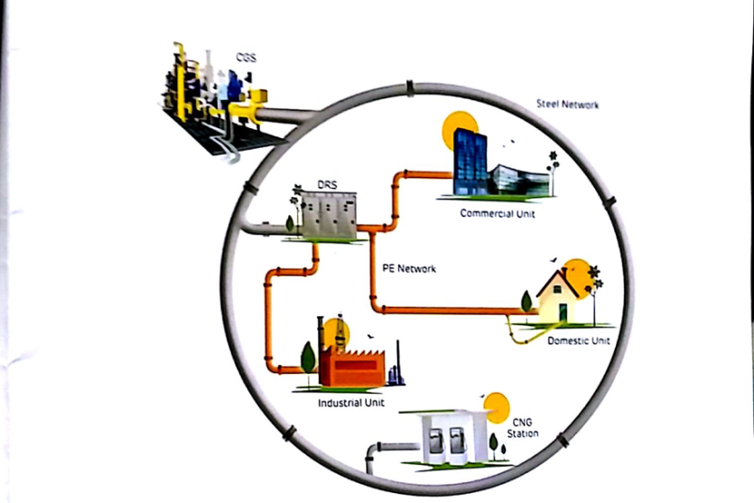

* Reduce the size of photos
* Remove 1st photo
* Just put 3 or 4 photos and change to other photos gallery
* Please give a link to the gallery to see other photos

1. **AMC and Maintenance**

* Change header photo
* Heading – **AMC and Maintenance**
* Two type of maintenance points shows in flow chart type
* Add good photos
* Just put 3 or 4 photos and change to other photos gallery
* Please give a link to the gallery to see other photos
* Avoid blank space
* Reduce the size of photos

**LPG Products**

* Change header picture
* Heading – LPG Products
* Remove header caption
* Change all picture titles
* Company name should be given to all products
* Reduce the size of photos

**Gallery**

* Change header picture and heading
* Adding good photos
* Photos can be shown by category in the gallery
* Reduce the size of photos

**Clients**

* Remove Repeat photos
* Reduce the size of photos

**Contact Us**

* Contact details showing different style
* Add Zonal office number (044-43574824, +91 7338881185) and email (sleschennai@gmail.com)
* Project office address and phone number (Trivandrum, Alappuzha, Kottayam, Thrissur, Calicut)
* Adding land number (PNG - & SLES – 0484 2989297)
* Add land number of LPG division, retail sales and PNG
* Add retail burner sales email and phone number
* Use correct map

**Additional :-**

* Add Suntec and reillo brochures